|  |  |
| --- | --- |
| GEN AI LEARNING  **Complete Generative AI Learning – New Year Challenge** | WRITTEN BY: ALOY |

***Day – 23***

Installing Docker for Windows 11

<https://youtu.be/WDEdRmTCSs8?si=0Vr1QwTwtL2A5ibG>

[Windows | Docker Docs](https://docs.docker.com/desktop/setup/install/windows-install/)

[Docker: Accelerated Container Application Development](https://www.docker.com/)

<https://learn.microsoft.com/en-us/windows/wsl/install-manual#step-4---download-the-linux-kernel-update-package>

**Step 1**: Go to the docker website and sign in with your Gmail account.

**Step 2:** Download the docker desktop

**Step 3**: Turn the Windows feature on and off Windows and enable the hyper-v & windows subsystem for Linux.

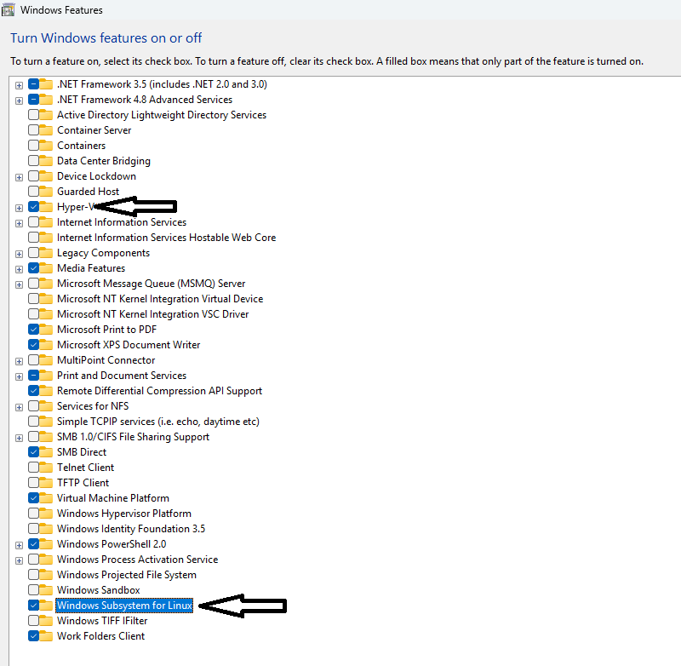

**Step 4**: run the wsl –status command in the command prompt to check whether wsl is properly configured or not.



if not follow <https://learn.microsoft.com/en-us/windows/wsl/install-manual#step-4---download-the-linux-kernel-update-package>

To confirm the default version to 2, you have to run

wsl --set-default-version 2

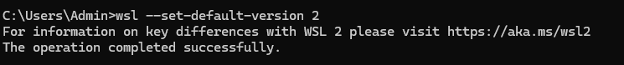

**Step 5**: run the docker desktop installer, keep the below configuration enabled, and click ok on the installer.

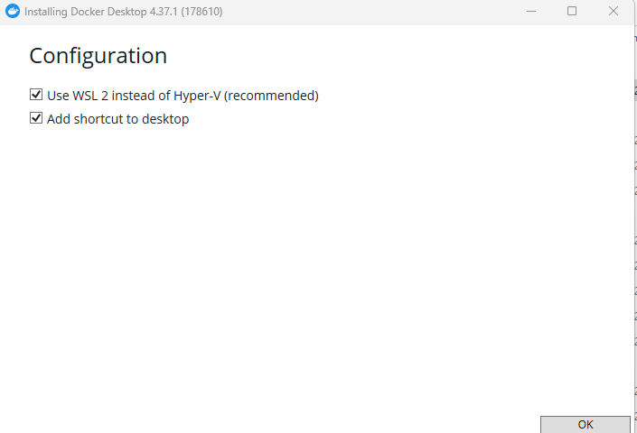

follow the instructions, and then the system will reboot, and the docker desktop will be ready.

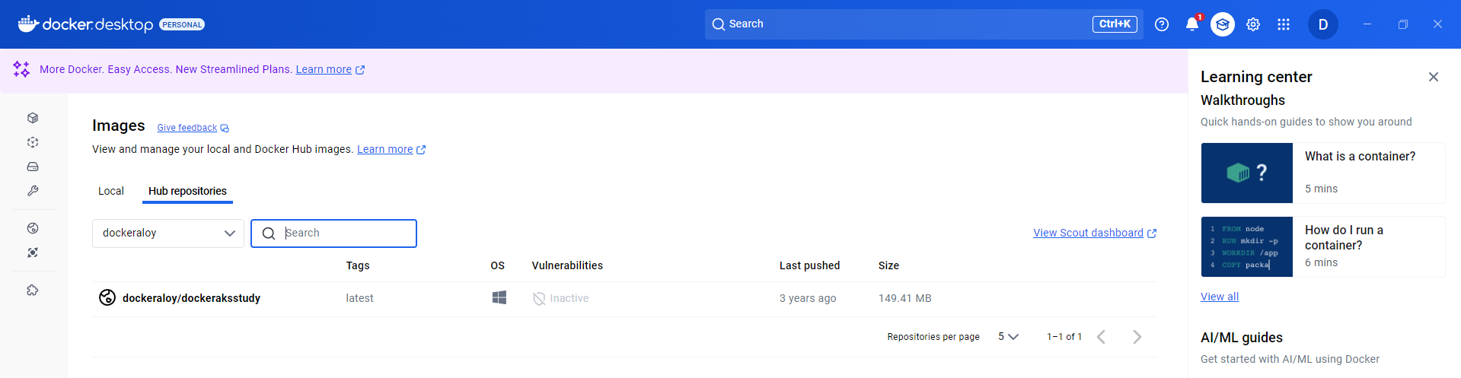

End